EXPERIMENT 4 —Step-wise Solution

PART A: LOAD DATA AND BUILD REPORT
Step 1: Open the Power BI Model
We opened the Power BI model created in Experiment 3 and verified that the required tables and relationships were available. We then prepared visuals for Sales by Region, Profit by Category, Sales by Segment, and Sales Trend by Year.

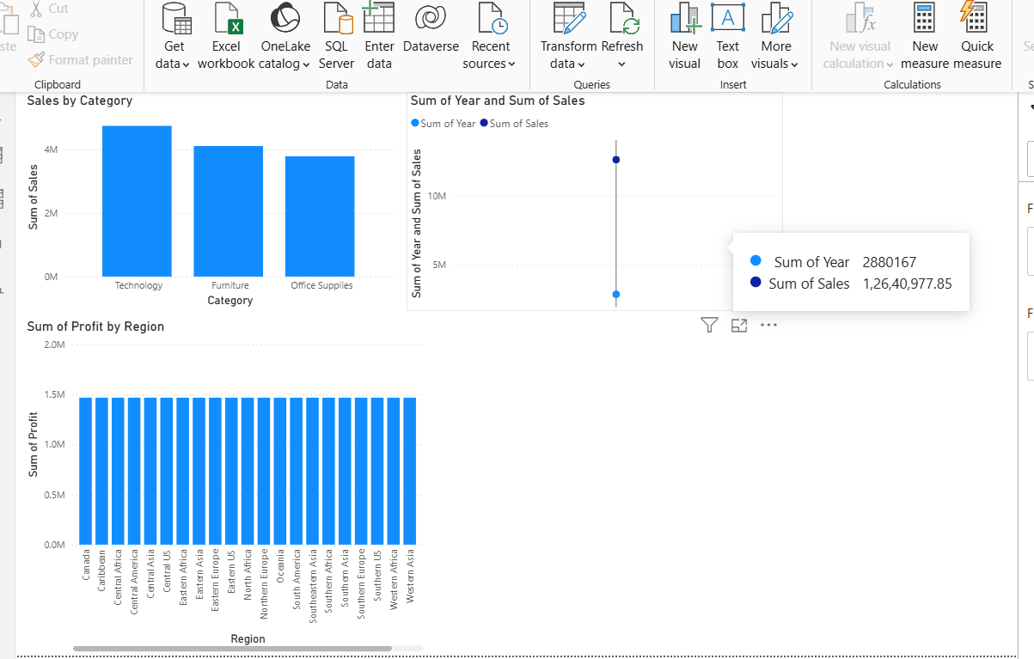
PART B: SLICE OPERATION
Step 2: Apply a Slice
A Region slicer was added to the report. We selected one region, such as West, and observed how the Sales, Profit, and Order values changed based on the selected region.
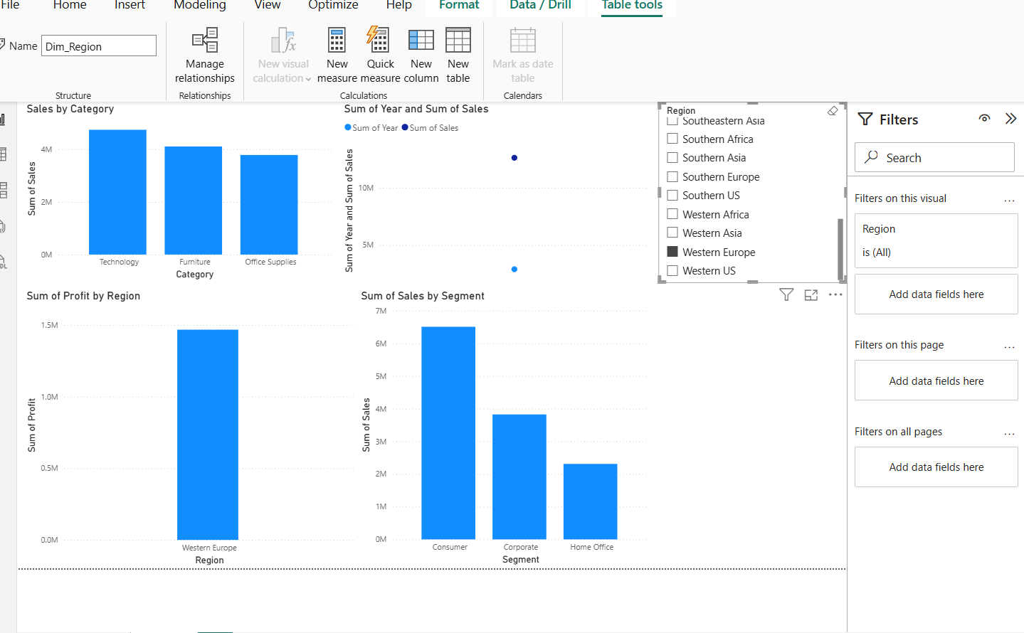

PART C: DICE OPERATION
Step 3: Apply Multiple Filters
Multiple filters were applied at the same time to perform a Dice operation. For example, we selected:
- Region = West
- Category = Technology
- Year = 2022
The resulting Sales, Profit, and Orders were analyzed for this specific combination.
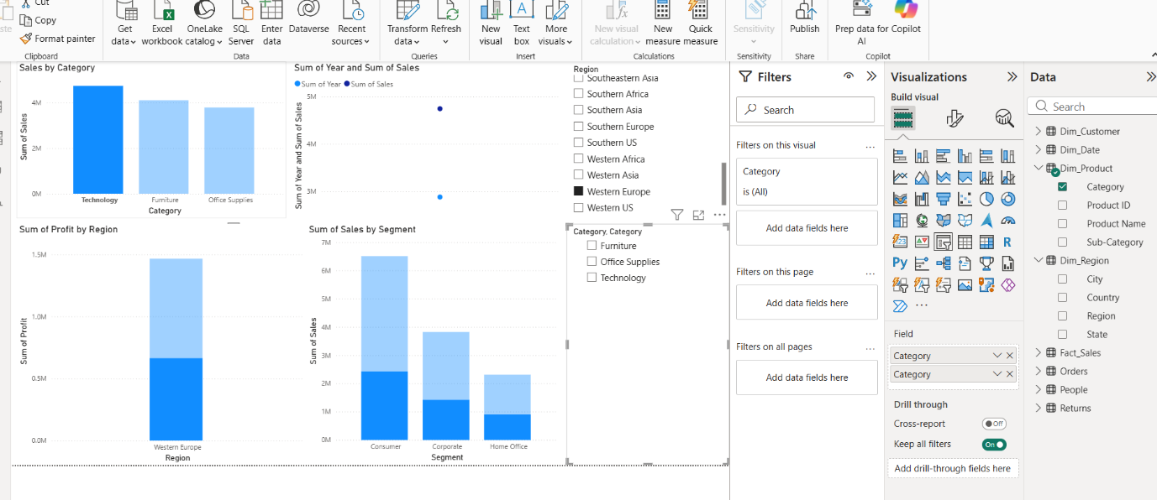

PART D: DRILL-DOWN OPERATION
Step 4: Analyze Data at Different Levels
A hierarchy was created using Region → State → City. The visual was then used in Drill-down mode to move from the regional level to individual states and cities.
This allowed us to examine sales performance in greater detail.
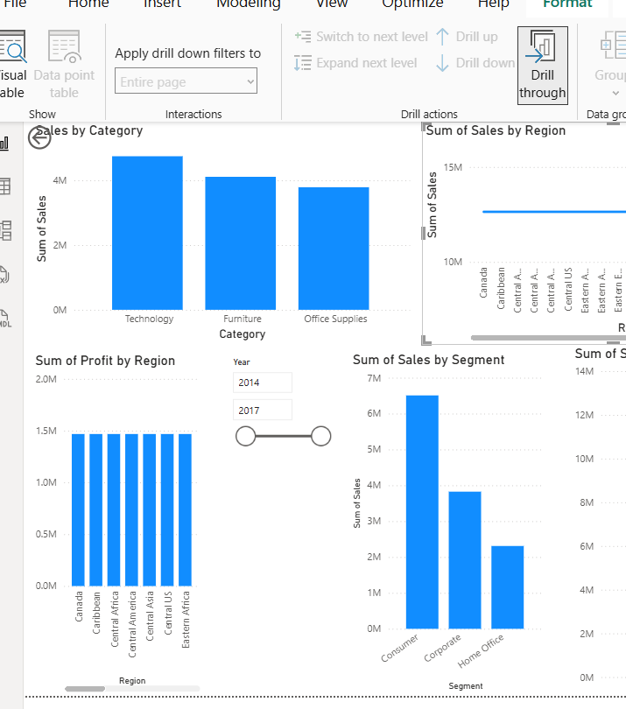

PART E: DRILL-UP OPERATION
Step 5: Return to Higher-Level Data
After analyzing the city-level information, we used Drill-up to move back from City → State → Region. The aggregated values at each level were compared to understand the overall business performance.
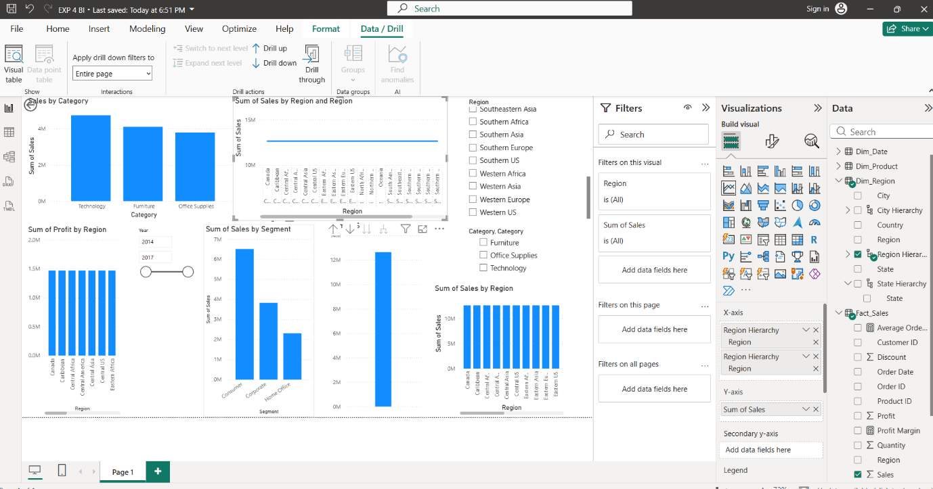

PART F: OLAP ANALYSIS
Step 6: Compare OLAP Operations
The results from Slice, Dice, Drill-down, and Drill-up were compared to understand how each operation provides a different view of the same business data.
A summary of the observations was prepared to show how these operations can support business decision-making.
